Energy Meter Monitoring Over IOT

Monitoring and keeping tracking of your electricity consumption for verification is a tedious task today since you need to go to meter reading room and take down readings. Well it is important to know if you are charged accordingly so the need is quite certain.
Well we automate the system by allowing users to monitor energy meter readings over the internet. Our proposed system uses energy meter with microcontroller system to monitor energy usage using a meter.
The meter is used to monitor units consumed and transmit the units as well as cost charged over the internet using Wi-Fi connection.
This allows user to easily check the energy usage along with the cost charged online using a simple web application. Thus the energy meter monitoring system allows user to effectively monitor electricity meter readings and check the billing online with ease.

Block Diagram:

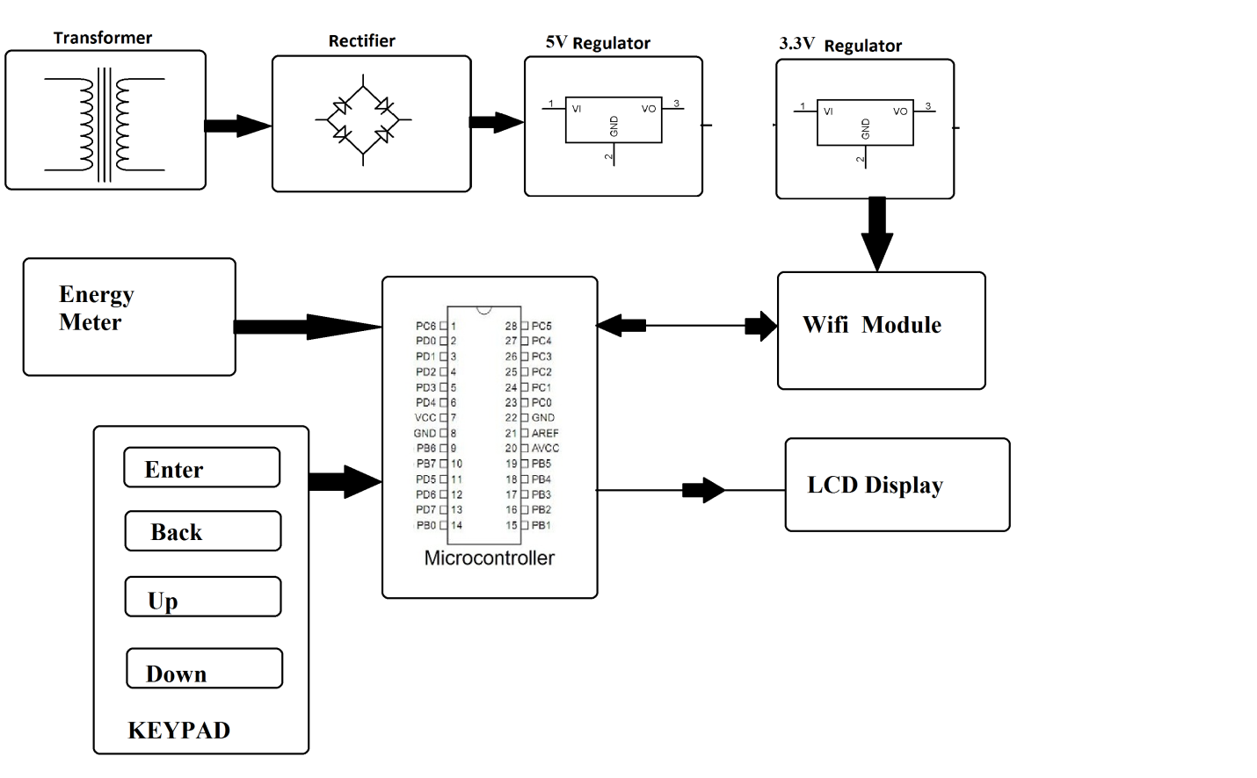

Hardware Specifications:
- Energy Meter
- Atmega 328 Microcontroller
- Wi-Fi Modem
- LCD Display
- LED’s
- Transformer
- Resistors
- Capacitors
- Diodes
Software Specifications:
- Arduino Compiler
- MC Programming Language: C
- IOTGecko

Reference
- http://ieeexplore.ieee.org/xpl/articleDetails.jsp?arnumber=7300834&queryText=meter%20iot&newsearch=true

- http://ieeexplore.ieee.org/xpl/articleDetails.jsp?arnumber=6804465&queryText=meter%20iot&newsearch=true

